Image Processing Assignment

Supervisor of Experiment: Dr. Tania Stathaki

Demonstrator: Sina Hafezi

Student: Ilias Chrysovergis, [ic517@ic.ac.uk](mailto:ic517@ic.ac.uk), 01449042

1. Image Transforms
2. Fast Fourier Transform (FFT)
   1. The log magnitude of the FFT of the cameraman:

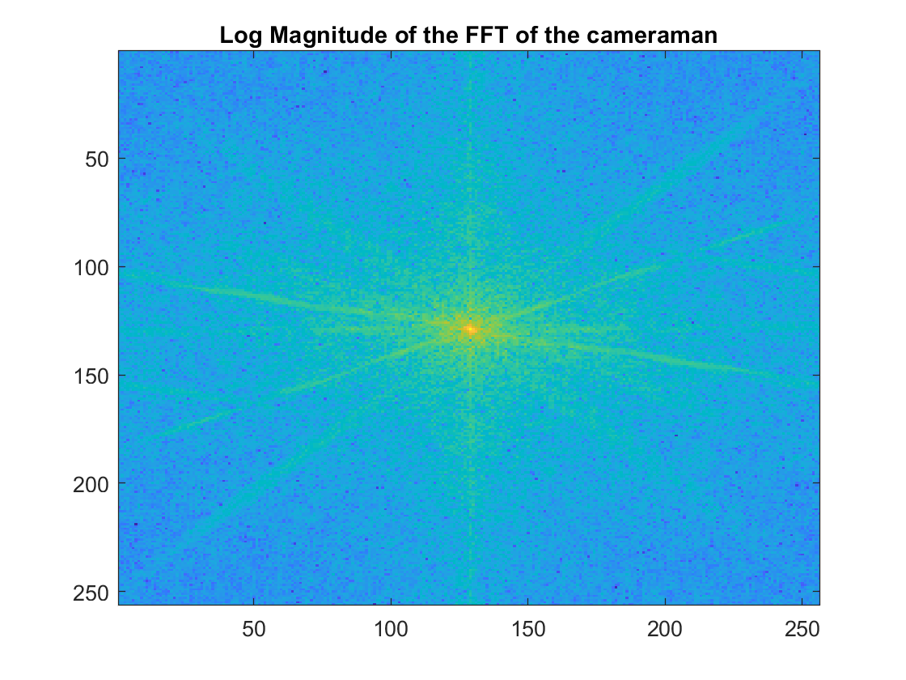

The low-indexed FFT coefficients possess higher values compared to the low-indexed, because there is more information in the lower frequencies than in the higher ones.

* 1. A grid of impulses and their FFTs:

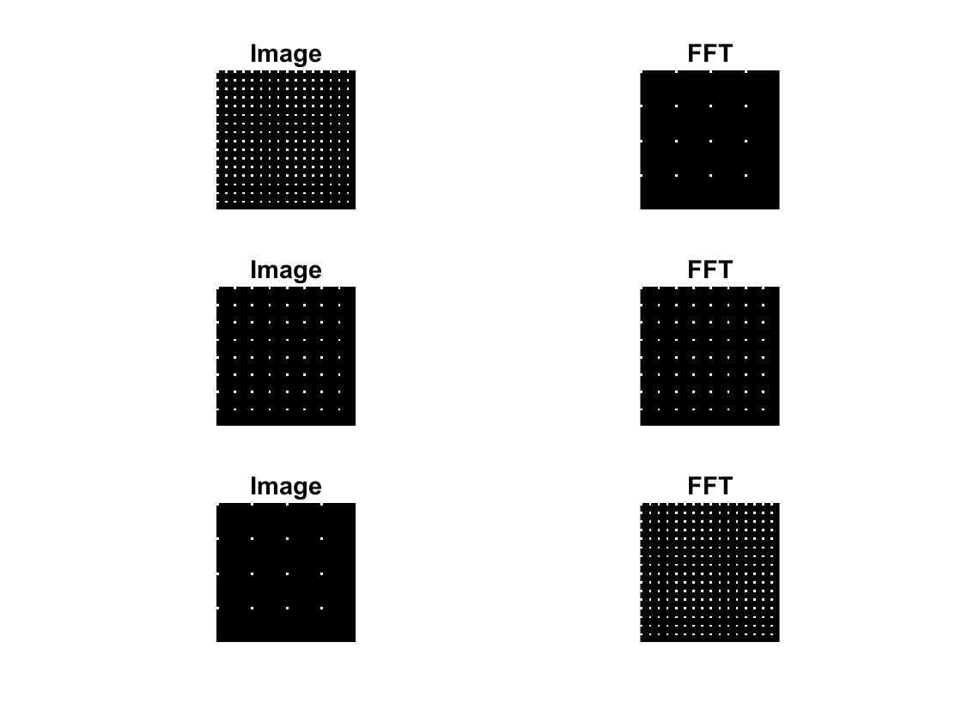

* 1. Combining the amplitude of a coin’s image with the phase of the cameraman image:

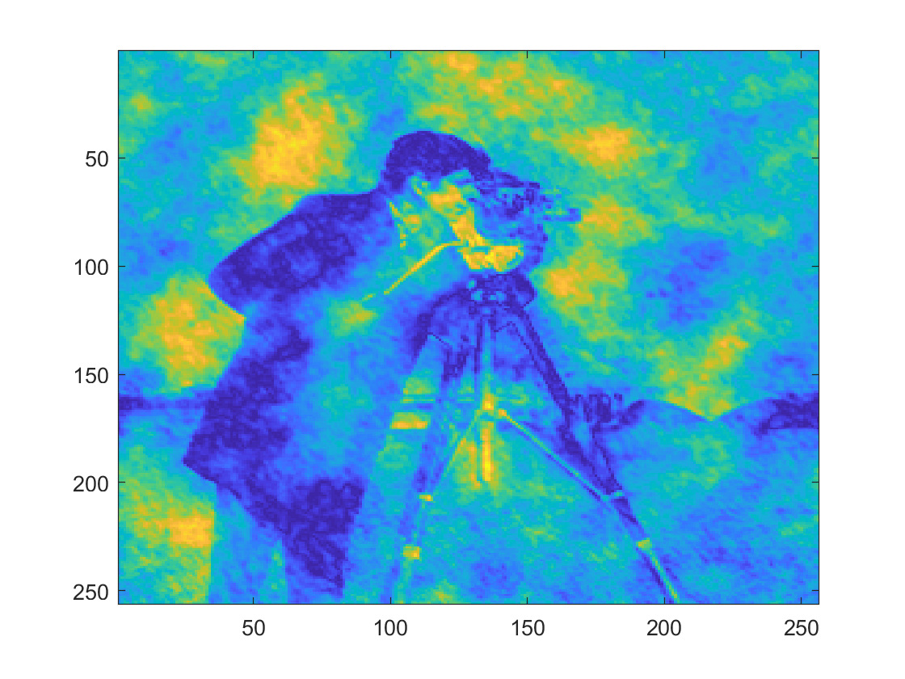

Most of the information is stored in the phase of the FFT, so this is the reason why the ifft of the combination gave a distorted version of the cameraman image.

1. Discrete Cosine Transform (DCT)
   1. The DCT of the “autumn” image:

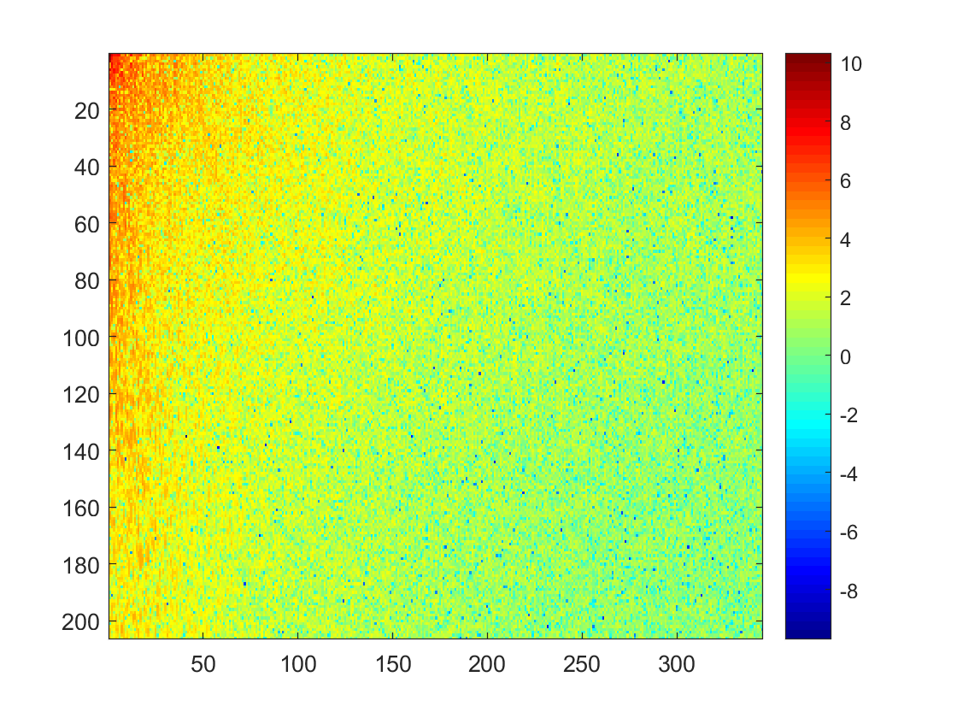

* 1. Most of the energy is concentrated within the upper left corner in DCT, while in FFT it is concentrated in the middle of the picture. FFT gives complex valued coefficients, while DCT gives real-valued ones.

1. Hadamard Transform

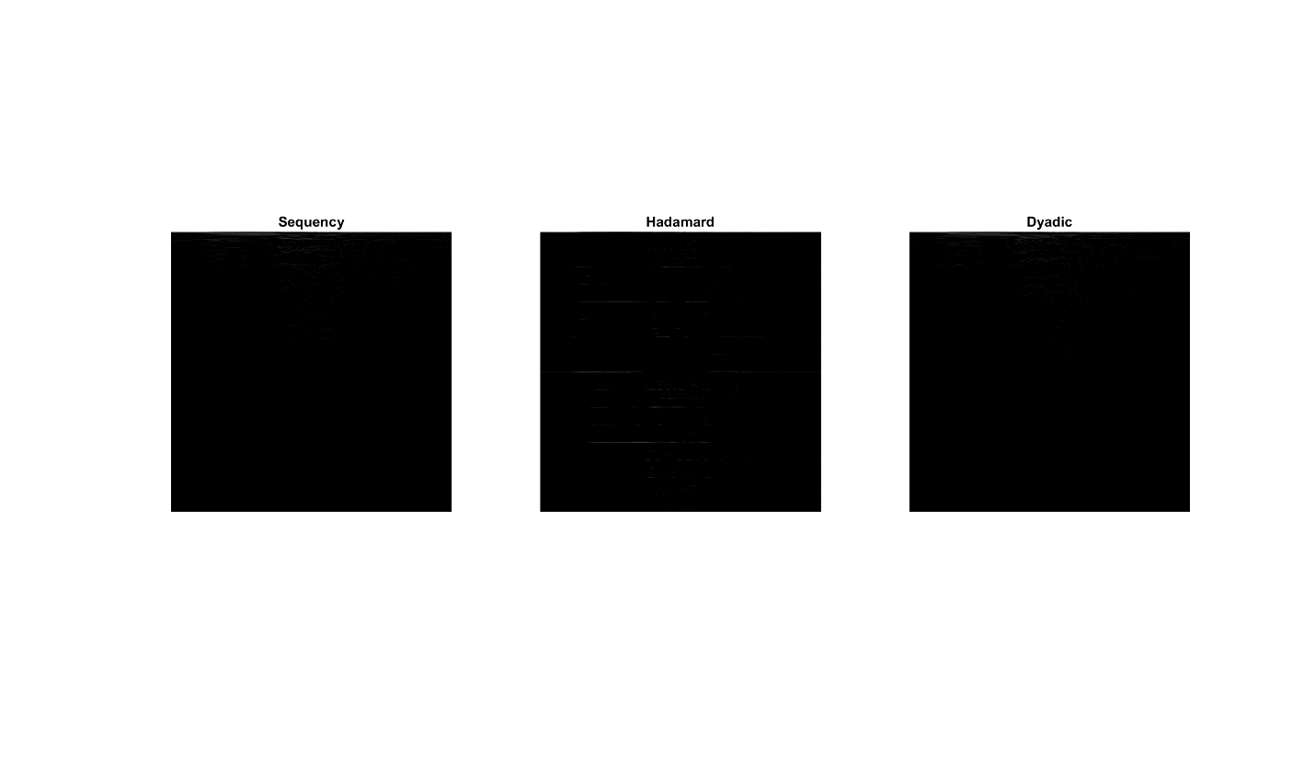

Most of the Hadamard coefficients are zero or very close to zero. In the Hadamard ordering we can see some non-zero values, while in the other orderings the most of the non-zero values are at the top.

1. Image Enhancement
   1. Histogram Equalization:

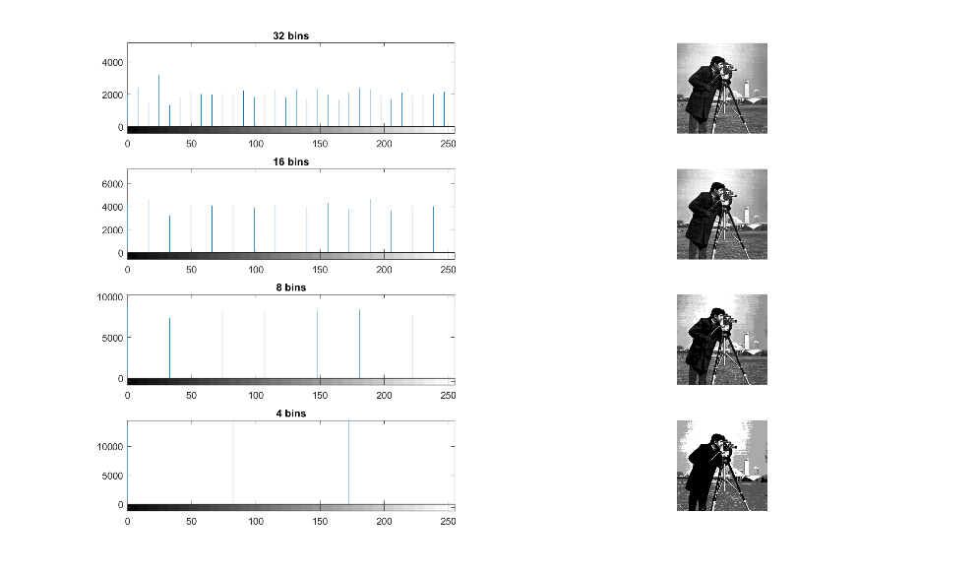

Decrease in the number of bins leads to distortion of the original image.

* 1. Histogram Modification:

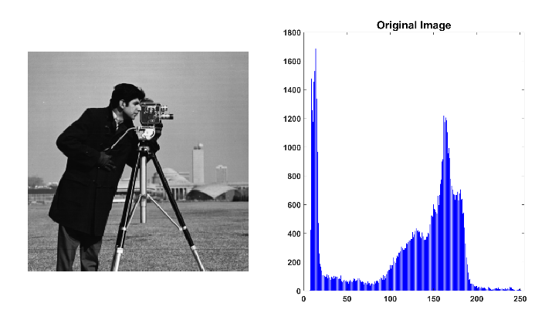

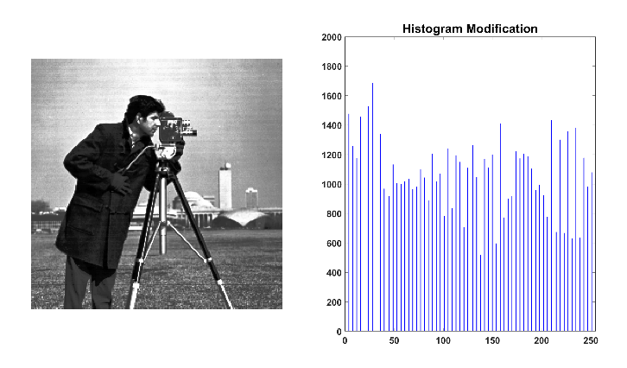

* 1. Edge detection:

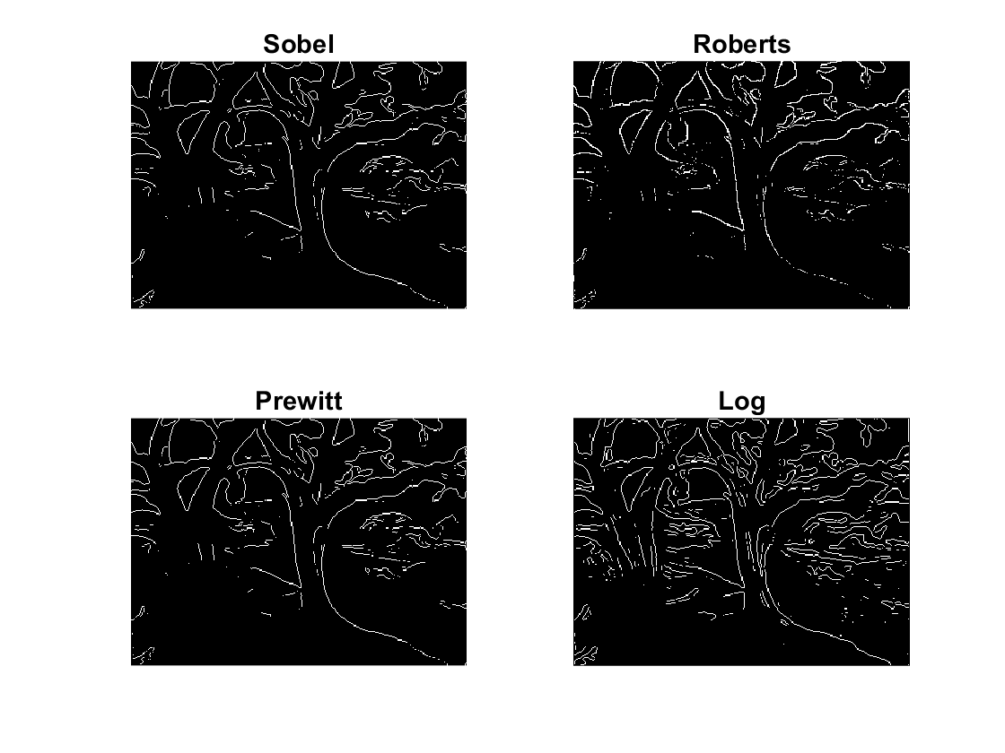

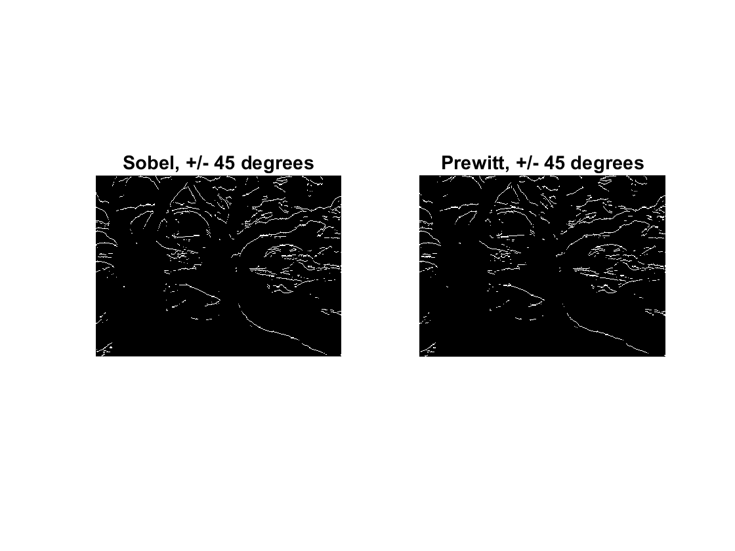

* 1. Median filtering:

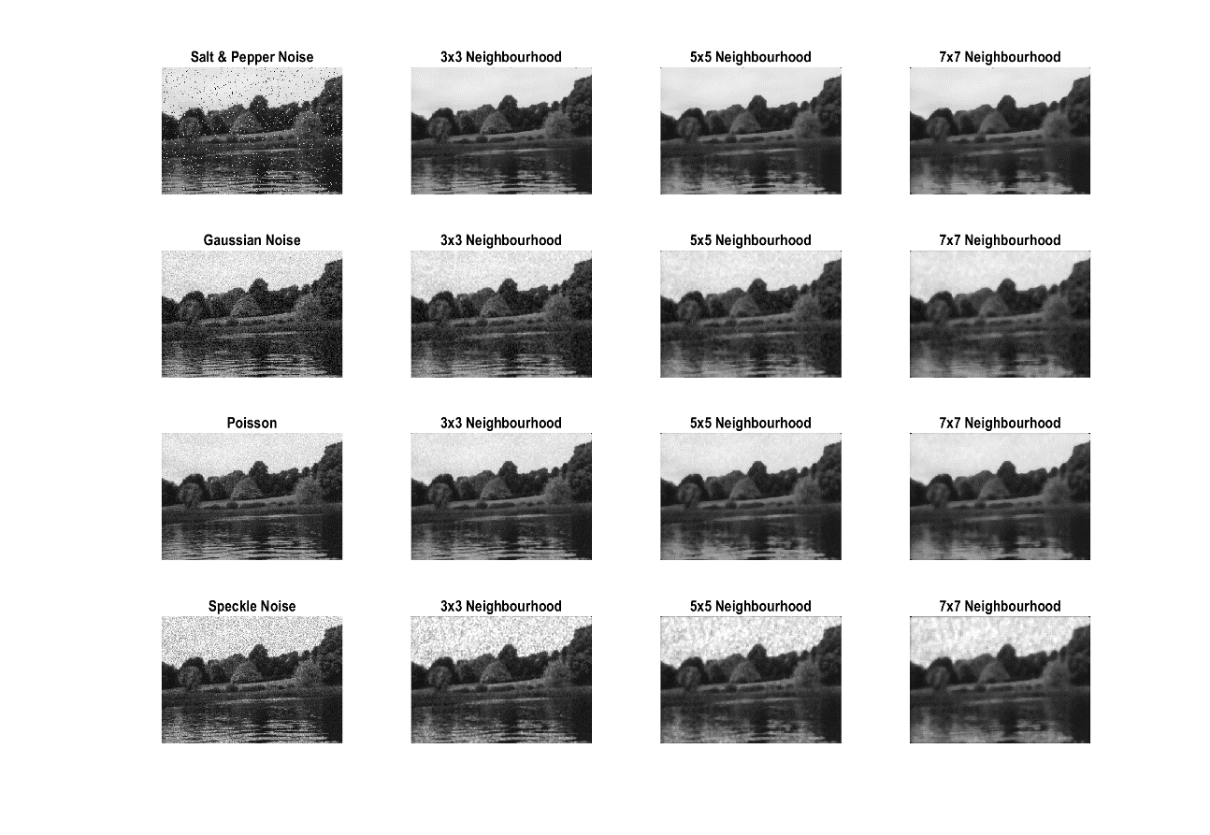

1. Image Compression
   1. Using the DCT without blocks. As the threshold increases the distortion is bigger.

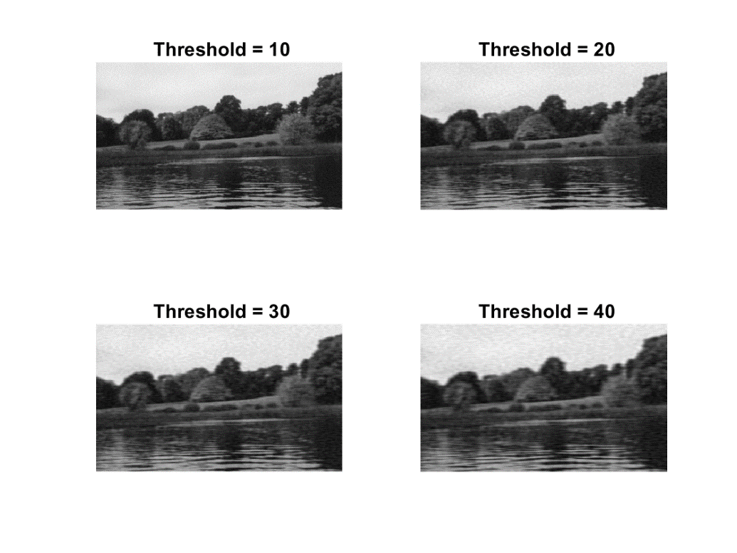

* 1. Using the DCT with blocks. As the threshold increases the image has bigger amounts of distortion. Furthermore, the 8x8 blocks provide the best reconstructions, while the 32x32 blocks provide the worst reconstructions.

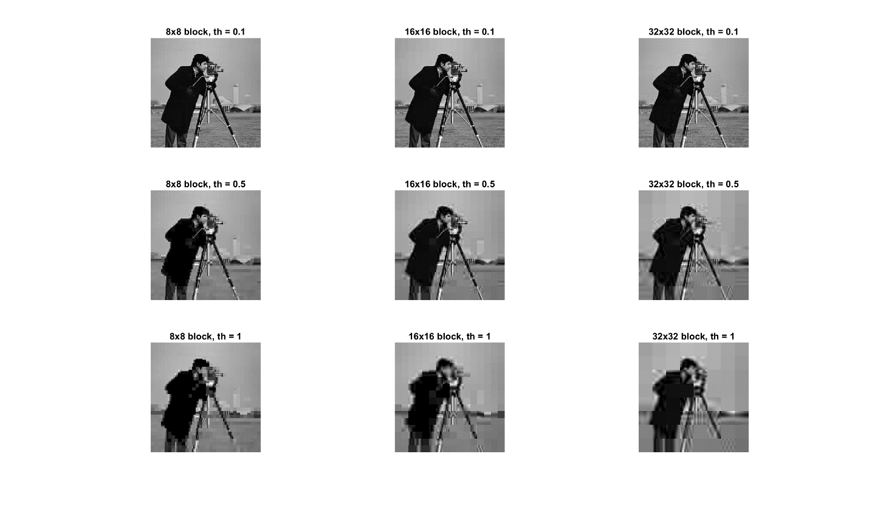

1. Design Exercise

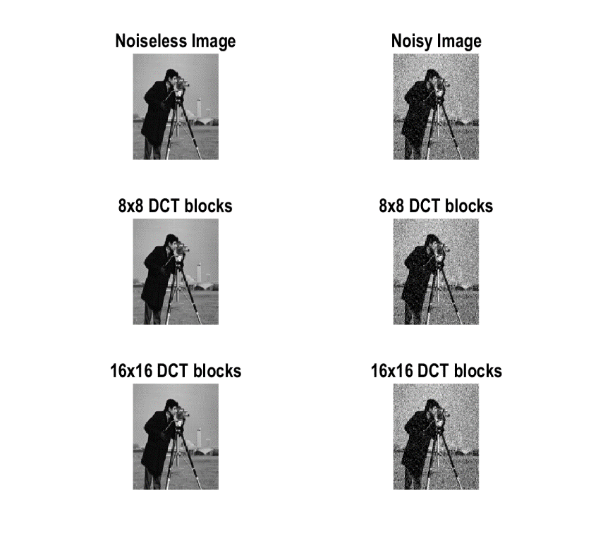

The appropriate block sizes and thresholds for visually acceptable reconstructed images, are given in the following table for the noisy and noiseless case:

|  |  |
| --- | --- |
| **Case** | **Threshold** |
| Noiseless/8x8 | 0.0025 |
| Noiseless/16x16 | 0.0032 |
| Noisy/8x8 | 0.034 |
| Noisy/16x16 | 0.034 |

1. Image Restoration

The original and the degraded images are shown below:

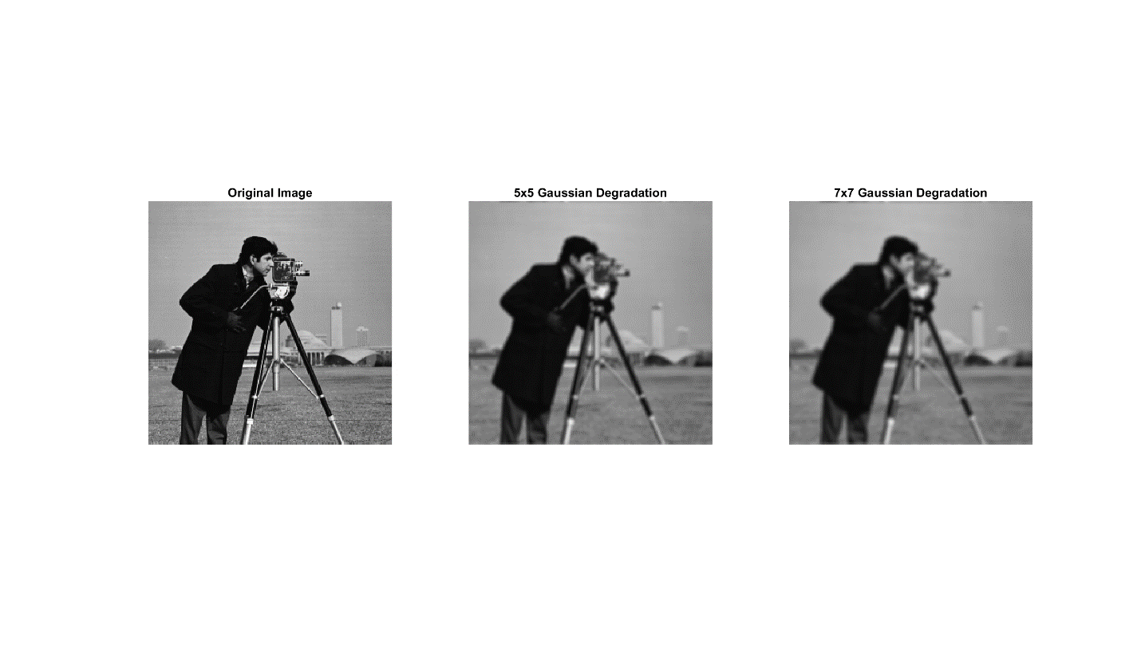

* 1. Inverse Filtering:

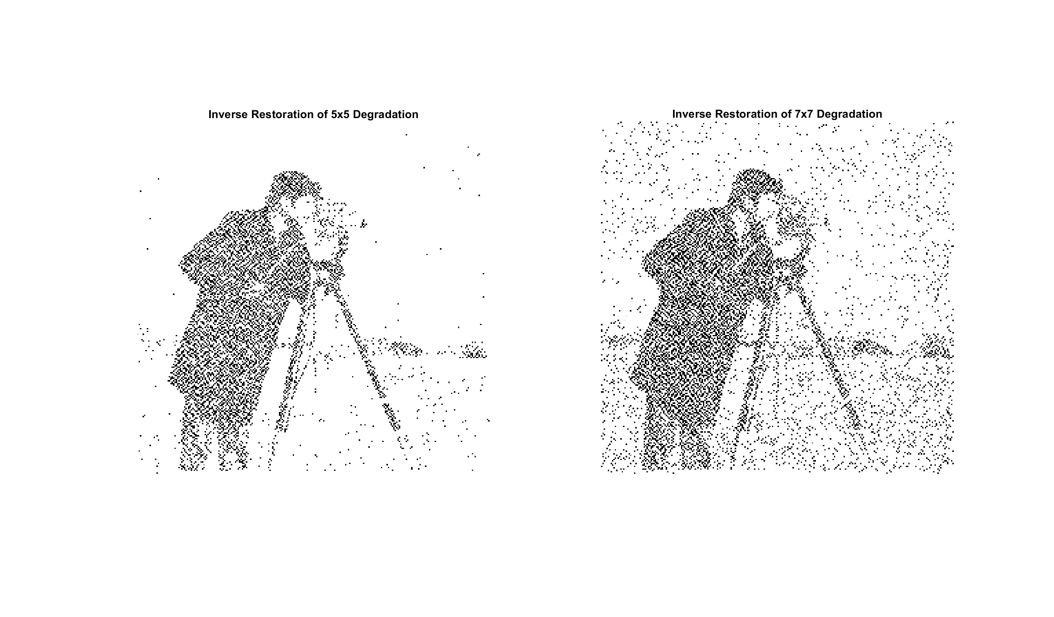

* 1. Wiener Filtering:

